IBM JAVA FULL STACK DEVELOPER BATCH

(OB – 17TH JUNE ’19)

LIST OF ALL THE FINAL PROJECTS

**NUTRITIUM**

**Problem Statement:** To create a web-based food delivery application in order to provide healthy food suggestions based on users’ preferences and physical information.

The project would be a webpage application that deals with stakeholders such as admin, customers and restaurants where the end user can sign up and create his personalized profile for receiving customized food suggestions. The application displays a user’s progress that is generated based on his/her preferences and orders.

Git: <https://github.com/sanga03/Spartans-FSD-IBM-SmartFood>

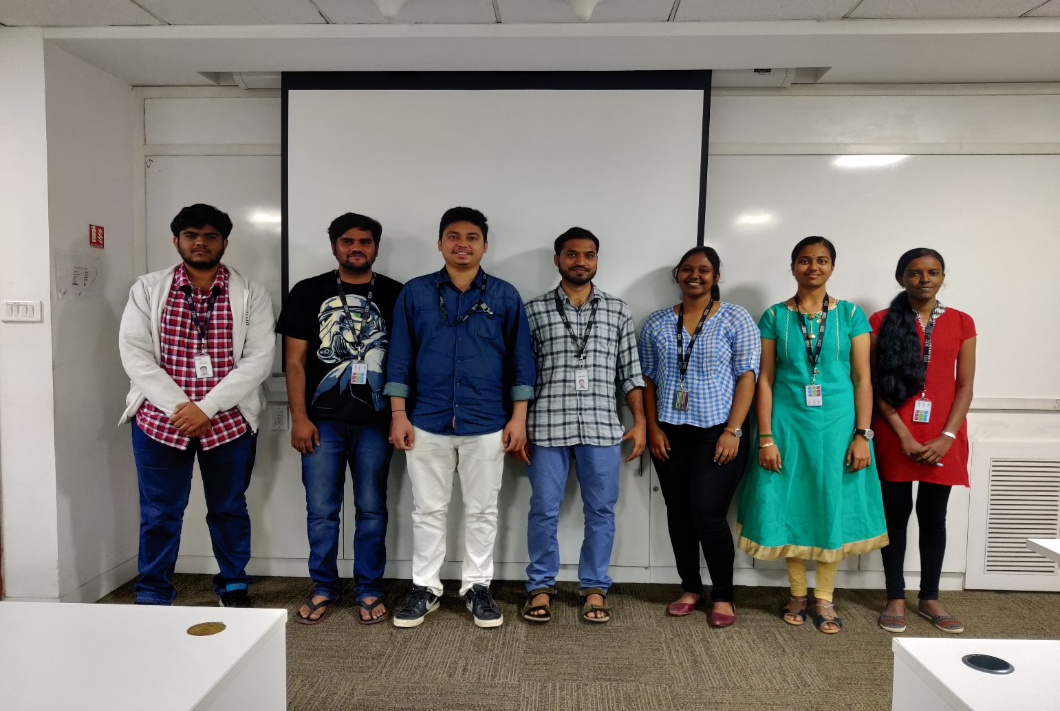

**Project Management System**

**Problem Statement:** We had a problem regarding the maintenance of the projects and the tasks under those projects. We had to develop a web application that would be single page application and will have the properties to assign the projects to the respective managers and that would be done by the admin of the organization. Maintaining the projects and their respective tasks and assigning them under various project managers is very difficult to achieve.

We made sure that we build the project and that would be a single page web application which will consider an organization’s various profiles and will deal them according to their role. The application will also give different access to different roles such as admin, manager, team leader and developer and the various roles will have operations like create, read, update and delete. For example, an admin will have the access to create a new user and admin can also edit or delete the user. Admin have also the authority to create the new project and assign it to the project manager. Just like a project manager will have the accesses to assign different tasks of the project to different employees and adding and deleting of tasks will also be taken care by the project manager. This hierarchy wise task distribution has been dealt with proper maintenance. In the future scope of this project, there will be an inbuilt notification component in the webpage. Overall it is an innovative idea that is executed by perfection.

Git: <https://github.com/viksin19/ibm-fsd-000gd6/tree/master/Project-Management-System/Project>

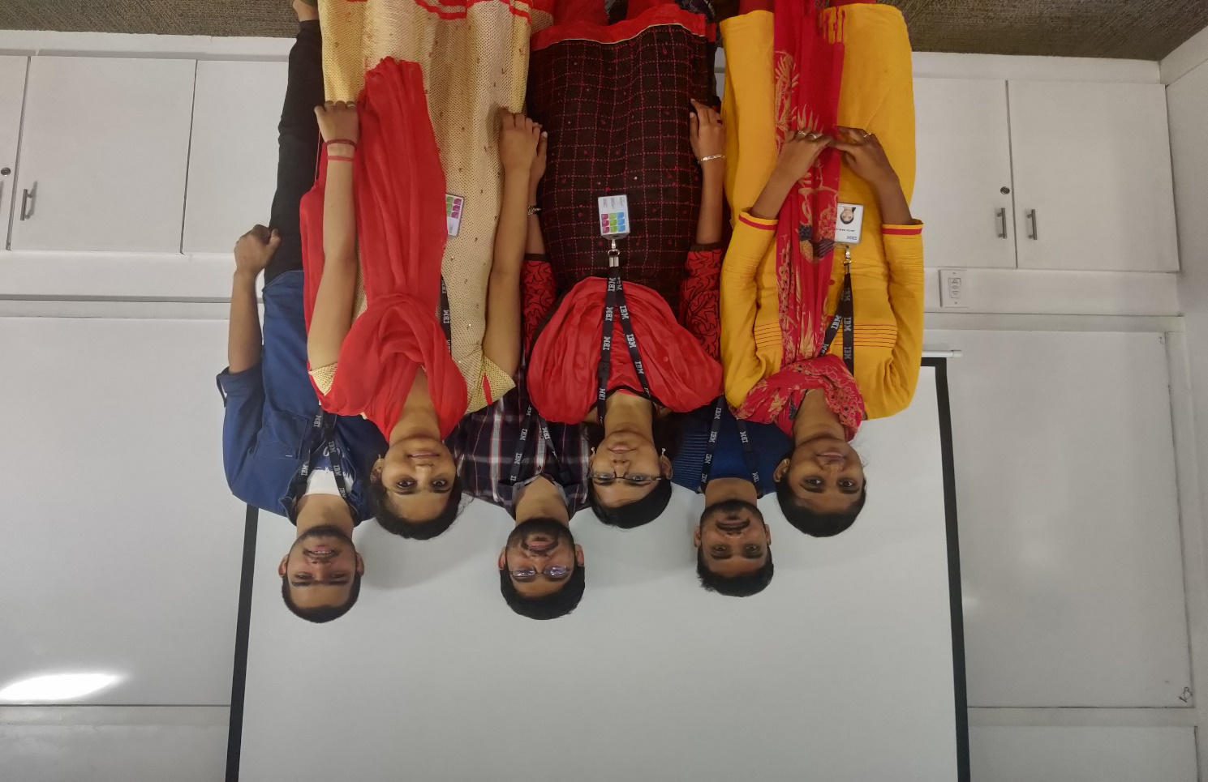

**Fitness Tracker**

**Problem Statement**: We need to develop Personal Fitness Tracker application, which is used to provide personalized workout and meal plans depending on the BMI and gender of the user.

In today’s world people usually don’t have enough time to look after their fitness and their lifestyle. So, the main objective of this project is to provide the personalized workout and meal plans depending on the BMI and gender of the user. According to the BMI calculated the user is provided with a customized workout plan and meal plan for 30 days. User can evaluate his/her performance with the help of graphs which compares the expected and actual results of the workout. There is also RSS feed which provides tips and tricks to stay fit and motivate the user for a better lifestyle. This application will help users to be able to stay fit and updated with a healthy lifestyle. This application also provides users with a personalized coach at a low cost to help improve their health and lifestyle. This application can be accessed from anywhere with no boundaries.The user can workout from any convenient location.

GitHub : <https://github.com/saket2408/fitnessTracker-project>

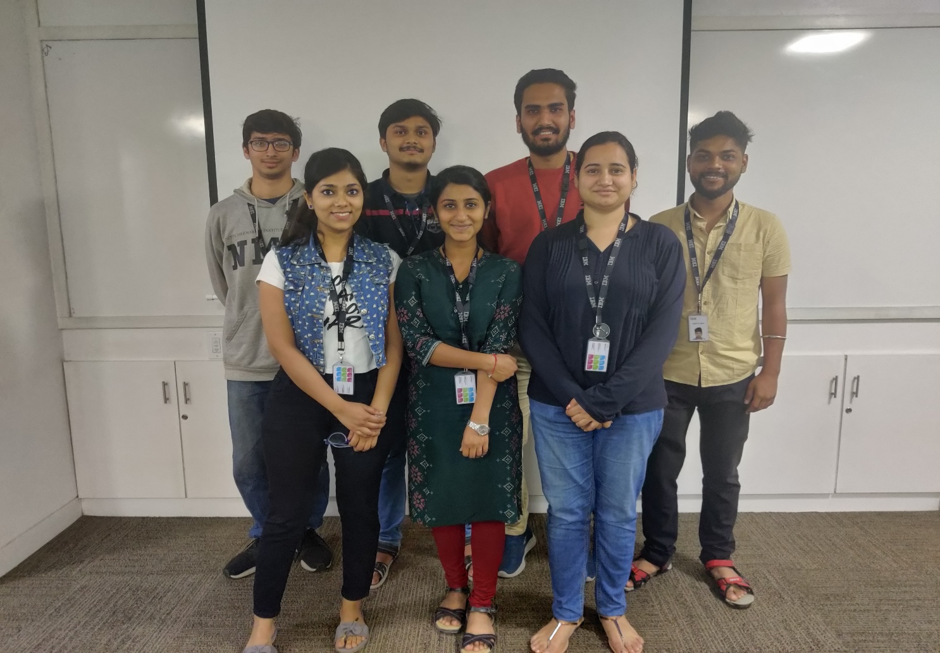

**RENTASTIC**

**Problem Statement** :To build a single page application Rentastic, that allows customers to rent products online.

On occasions of house shifting and on many other situations people feel the necessity of renting some furniture, electronics or automobiles to sort out the problems. So if it is possible to design or develop a web based application for availing products for rent whenever and wherever possible, then it will be beneficial for both renter and customer. The RENTATSIC is the online rental cart system to rent household furniture, electronics and automobiles online within few clicks only. The renter uploads the products for the customers to rent. The customer selects the products that he is interested in renting. The system has various furniture, electronics and automobiles. As per the customer order and comfort, he place the order and rental products are delivered as per the location within the area.

Git : <https://github.com/demanda1/Rentastic>

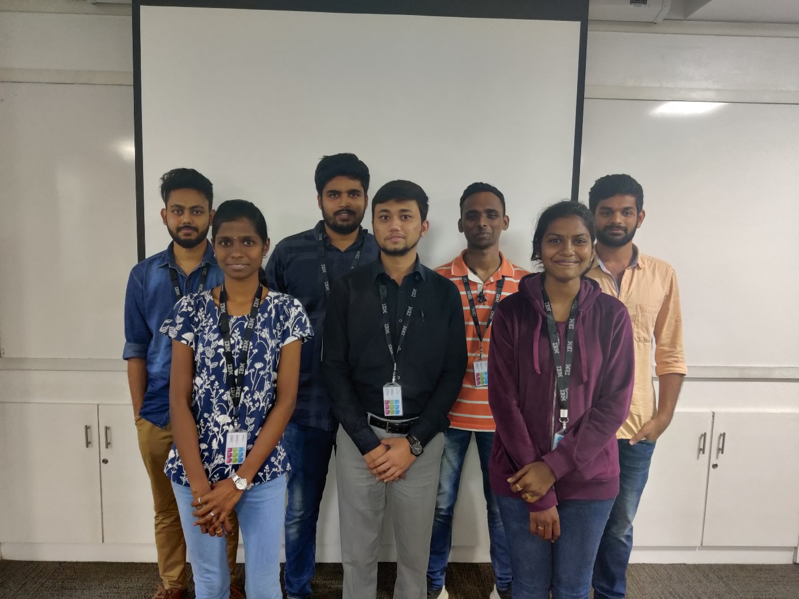

**SKILL TRACKER**

**Problem Statement:** John Dempsey works in an IT company. He is an new age HR Academic Manager. Few of his roles and responsibilities includes:

Keeping track of skill of individual Full Stack Engineers.To use the single page solution to keep track of associate skills. The proposed solution (Skills Tracker) will try to provide the above-mentioned features.

The Skills Tracker should be a Single Page Application (SPA). Using this internal portal John Dempsey will be able perform following operations:

**Search Associate**: John will be able to search associate with following criteria:

Search by associate name

Search by associate ID

Search by Email ID

Search by Mobile Number

Search by Skills

**Add new Associate:** John will be able to add new associate and its respective Full Stack Development Skills.

**Edit, Delete & View Associate:** The associate information which is searched can be updated, deleted ,viewed and communicated through email.

**Add Skill:** It will allow John to add new skills so that it can be used in “Add New Associate” page.

**Git :** https://github.com/PriyaRavi97/Skills-Tracker

